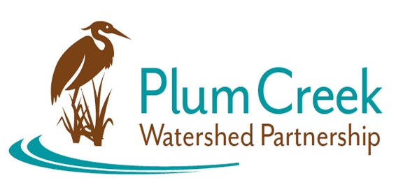

Plum Creek Watershed Partnership
Steering Committee Meeting
9 AM – 11 AM
Thursday, October 19th
Edgar B. Davis Southside Clubhouse
1000 S Magnolia Ave, Luling, TX 78648
Meeting Summary
- The Watershed Coordinator (WC) called the meeting to order and introduced Jana Gray from GBRA to speak on the Guadalupe River Habitat Conservation Plan (GRHCP).
- Mrs. Gray explained the major components of the GRHCP and the need for endangered species protection as related to human activities that would cause take (as defined in the Endangered Species Act). Six species are covered by the HCP with three avoidance species. While surveying for mussels, a covered species, the Guadalupe Orb, was found in Plum Creek along with other non-covered species of mussels. More information about the GRHCP is available on the GBRA website.
- The WC presented a draft of the 2024 Watershed Protection Plan Update to the Steering Committee. Major updates to the WPP as compared to the 2022 Update were discussed. These changes include the addition of new updated figures, a ten-year trend analysis of water quality data, and updated tables.
- The Steering Committee and WC discussed a plan of action for the PCWP Work Groups. The Civil Work Group will focus on the development of a guidebook for watershed protection and development. The Natural Environment Work Group will focus on strengthening relations with the counties and looking at potential county regulations to benefit watershed protection.
- The Steering Committee and WC discussed the plan for the next Public Stakeholder meeting. The WC will find a speaker to present on the potential topics of advocacy, civil engagement or One Water.
- The WC discussed upcoming events and adjourned meeting.

Next Steering Committee Meeting: Spring 2024
Location: TBA

Funding for this effort is provided through a federal Clean Water Act nonpoint source grant administered by the Texas Soil and Water Conservation Board from the U.S. Environmental Protection Agency.

