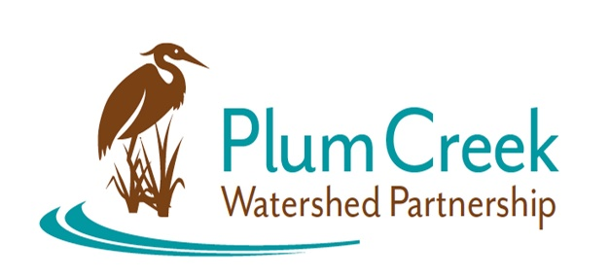

Plum Creek Watershed Partnership
Steering Committee (SC) Meeting

June 3, 2022 9:30 to 12
Kyle Fire Station 1

Meeting Summary

- Christina Lopez welcomed the SC members
- Christina provided an update to the WPP, including recent and upcoming programs and events, and results from the WPP priority planning form
- Christina facilitated a discussion on next steps for the WPP and forming workgroups.
- Draft workgroups were crafted.
- Tour of Kyle’s WWTF was postponed.

