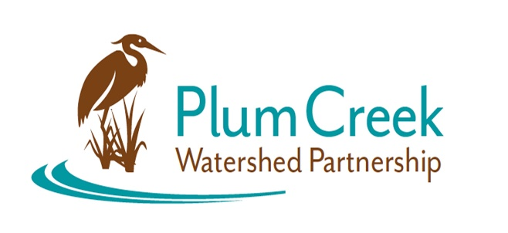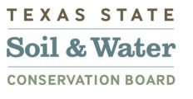

**Plum Creek Watershed Partnership**

**Public Stakeholder Meeting**

5:00 PM – 7:00 PM

Thursday, July 25, 2024

Kyle City Hall

100 W Center Street, Kyle, TX 78640

**Meeting Summary**

* The Watershed Coordinator (WC) commenced the meeting by providing a brief overview of the Plum Creek Watershed. The WC discussed the state of the watershed and highlighted Texas Commission for Environmental Quality’s (TCEQ) Integrated Report. Clear Fork Plum Creek was included for the first time in the draft 2024 Integrated Report.
* The WC presented on all the recent clean ups and workshop that had taken place since the last Public Stakeholder Meeting (Feb 28, 2024).
* The guest speaker, New Braunfels Utility’s One Water Coordinator, gave their presentation “One Water Regional Collaboration” covering the One Water efforts in Texas.
* One Water is an integrated planning and implementation approach to managing finite water resources for long-term resilience and reliability, meeting both community and ecosystem needs. The practice of One Water is a new development approach to protecting and conserving water resources.
* There are three main applications of One Water. It can be applied to building projects, infrastructure projects, and planning projects. With each application, there is a multitude of ways to use One Water as it is meant to be an intentional and comprehensive look at all ways water can be best managed and then selecting what best fits the project at hand.
* A goal of One Water is to not only support the environment but also be economical and supportive of the community. This is referred to as the triple bottom line.
* The guest speaker highlighted projects in Central Texas that have incorporated the practice of One Water. This included Blue Hole Primary School, New Braunfels GBRA headquarters and Landa Aquatics Center parking lot.
* Here listed are links that the guest speaker shared during their presentation
  + <https://texaslivingwaters.org/deeper-dive/one-water-in-the-texas-hill-country/>
  + <https://watershedassociation.org/library/>
  + <https://shorturl.at/GfseC>
  + <https://www.youtube.com/watch?v=LMmIVsBN83g>
* After the guest presentation the WC guided a discussion on the way One Water could be integrated into the watershed and projects that could include implementation of the Plum Creek Watershed Protection Plan and One Water.
* In discussion, youth education was identified as way to bring more awareness to water issues. The stakeholder group discussed organizing a spring/summer school celebration that has water as the focus of the event, being fun and educational.
* The WC discussed ongoing opportunities in the watershed to be involved with the Plum Creek Watershed Partnership and other water quality efforts. Texas Stream Team is a community scientist water quality monitoring effort always ongoing in the Plum Creek Watershed.
* The WC, along with a volunteer from TreeFolks, discussed the TreeFolks’ Central Texas Floodplain Reforestation Program. This program offers free trees and planting for landowners in floodplain/ riparian areas.
  + <https://www.treefolks.org/reforestation-services/central-texas-floodplain-reforestation-program/>
* The WC concluded the meeting by announcing upcoming events and discussing what to expect at the next Public Stakeholder meeting.

Next Public Stakeholder Meeting: Winter 2025

Location: TBA

Funding for this effort is provided through a federal Clean Water Act nonpoint source grant administered by the [Texas Soil and Water Conservation Board](https://www.tsswcb.texas.gov/tsswcb-home-page) from the [U.S. Environmental Protection Agency](https://www.epa.gov/).