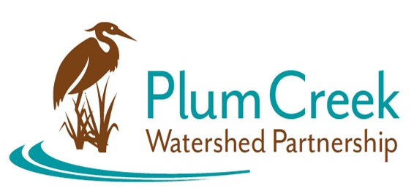
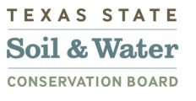

Plum Creek Watershed Partnership
Steering Committee Meeting

5 PM – 5:45 PM
Thursday, July 13th
Lockhart State Park Recreation Hall
2012 State Park Rd, Lockhart, TX 78644
Meeting Summary
- The Watershed Coordinator (WC) started the meeting and discussed changes in Steering Committee membership. New individuals were selected by funding partners to have different representative on the Steering Committee, specifically the City of Uhland and Caldwell County. Also, some of the funding partners had proposed alternate members for Steering Committee meetings.
- The new Steering Committee members and alternates were voted onto the Steering Committee by majority.
- The WC gave updates to the Steering Committee from the Civil Work Group meeting and Natural Environment Work Group meeting.
- There was discussion around potentially tasking the work groups with developing a framework for permitting entities in the permitting process and development agreement process. This framework would be a tool to guide permitting entities in making sure there is consideration to Watershed Protection Plan (WPP) and implementing best management practices when new developments come to the watershed. Also discussed was the general need for the Partnership to engage with permitting entities. This will be discussed with the Civil Work Group.
- The WC notified the Steering Committee that work has started on the biennial update to the WPP. A draft of the 2024 WPP update will be prepared for the next Steering Committee meeting in October.

Next Meeting: October 2023
Location: TBA

Funding for this effort is provided through a federal Clean Water Act nonpoint source grant administered by the Texas Soil and Water Conservation Board from the U.S. Environmental Protection Agency.

