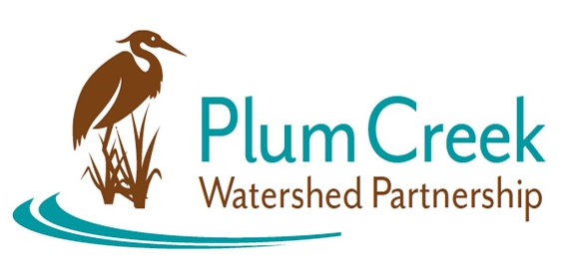
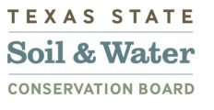

Plum Creek Watershed Partnership
Public Stakeholder Meeting

5:45 PM – 7 PM
Thursday, July 13th
Lockhart State Park Recreation Hall
2012 State Park Rd, Lockhart, TX 78644
Meeting Summary
- The Watershed Coordinator (WC) called meeting to order and began with introductions. The Steering Committee members then introduced themselves to the stakeholders.
- The WC did an overview of the Plum Creek Watershed, its current water quality status, and the Plum Creek Watershed Protection Plan (WPP). The need for stakeholder input and participation was highlighted and how it is helpful for implementing the WPP and updating it. The biennial update to the WPP will be released in 2024.
- The City of Kyle gave a presentation on their MS4 Stormwater Program. The City of Kyle will be renewing their MS4 permit with Texas Commission on Environmental Quality (TCEQ). City of Kyle asked for stakeholder input. City of Kyle explained some other ordinances unique to the city that support best management practices.
- Stakeholders asked the City of Kyle questions about illicit discharge issues and the city’s enforcement of violation. Also discussed was the City of Kyle’s and Hays County’s Household Hazardous Waste Removal days and programs available.
- The WC lead an activity called “What about my watershed?” where stakeholders went around the room answering various watershed focused questions that were written on posters. After answers were written on the posters, the WC read them off and added commentary to some of the answers.
- Upcoming events were promoted.

Next Meeting: January 2024
Location: TBA

Funding for this effort is provided through a federal Clean Water Act nonpoint source grant administered by the Texas Soil and Water Conservation Board from the U.S. Environmental Protection Agency.

