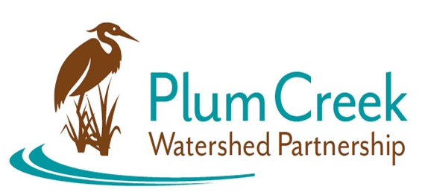
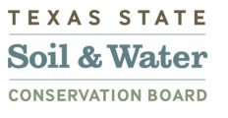

Plum Creek Watershed Partnership
Steering Committee Meeting
Thursday, January 12th 9:30 AM – 12 PM
Lockhart State Park Recreation Hall

Meeting Summary
- Sean Melvin Welcome the Steering Committee (SC) members and guest.
- Sean introduced himself to the SC members as the new Watershed Coordinator for the Plum Creek Watershed Partnership. The members then proceeded to introduce themselves to Sean.
- Dennis Engelke, Caldwell County’s Grant Administrator, introduced himself and gave a brief history and description of the upcoming annual Feral Hog Bounty Claim event for Caldwell County. The event will run from February to August.
- Sean provided a recap of what was discussed last SC meeting (June 3rd, 2022) and went over the results of the Watershed Priority Planning survey.
  - SC members discussed the priorities and wastewater permits that did not meet the recommended standards. Virginia Parker raised concerns about the Kyle WWTP permit that is under review by TCEQ.
  - SC members discussed possible avenues for addressing WWTP permits that do not meet recommended standards.
- Sean and Elizabeth Edgerton, GBRA Water Quality Program Supervisor, informed the SC member about the loss of Polonia WSC as a funding partner and that they are in contact with Aqua WSC, the company that acquired Polonia WSC.
- Sean informed the SC members about the new 319 grant contract that was awarded to the Plum Creek Watershed Partnership.
- Sean and Elizabeth spoke to the SC members about the updated Interlocal Agreement and the SC Ground Rules.
  - Sean, with the SC, will update the Ground Rules to update the language and provide changes to rules. They plan to finalize the Ground Rules at the next meeting.
- The Work Groups were discussed by the SC member. Work Groups were drafted last meeting.
  - SC members discuss changes to the Ground Rules in relation to the Work Groups.
  - SC member determined that it may be best to consolidate the 6 Work Groups into 2 Work Groups defined as: Urban Stormwater/Wastewater/ Regulations & Policies Work Group and Agricultural/ Wildlife Work Group. Both will encompass an aspect of education and outreach.

