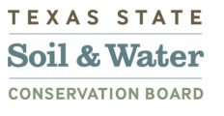
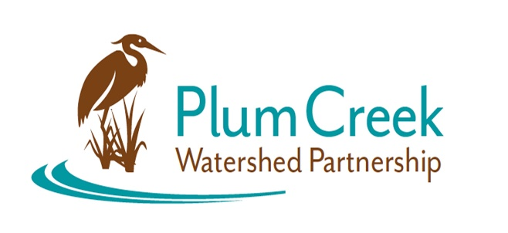

Plum Creek Watershed Partnership
Steering Committee (SC) Meeting
Zoom
Thursday, September 23, 2021
10:00

Notes
- Christina welcomed the SC members and asked that they sign in via Google Sheets
- A brief overview of the agenda was given
- Introductions of SC members and guest, Dr. San Hwang
- Presentation included:
  - Stakeholder Survey Results
    - Urbanization and illegal dumping are perceived as greatest threats to water quality
    - Most stakeholders want riparian education, among other workshops and programs
  - Agriculture and Urban Nonpoint Source Pollution
    - Water quality management plans and new conservation technician
    - Development projects and population growth
    - Feral hog control – Summer Program Results
  - Current Happenings
    - Keep Lockhart Beautiful Fall Cleanup, new monitoring group (Plum Creek Stewards), new book club, Plum Creek Wetlands Preserve
  - Opportunities for Plum Creek with Dr. San
    - Floating raft – phytoremediation
    - Pervious BLOCK
    - Water quality monitoring
- SC Updates:
  - City of Kyle WWTF is on schedule for completion March 2022
    - Will include several low impact developments (LID) and green infrastructure components, as well as public education
  - City of Kyle Police Department
    - Will include LID: rain water harvesting, bioswales, and more
- Discussed committee structure, how to add new members, and mentioned working groups

