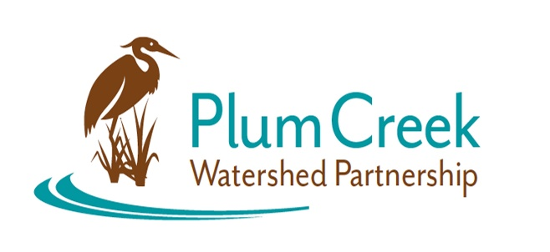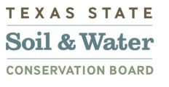

**Plum Creek Watershed Partnership**

**Steering Committee Meeting**

9:00 AM – 11:00 AM

Tuesday, October 15, 2024

Kyle City Hall, Falcon Room

100 W Center Street, Kyle, TX 78640

**Agenda**

**9:00** Sign in and Refreshments – Call meeting to order

* PCWP Updates
* GBRA Project Manager updates
* Feral Hog Trap Loan Program discussion
* Youth Education discussion: WaterFest
* Adult Education discussion
* Opportunities and events in the watershed

**11:00** Adjourn

Next Public Stakeholder Meeting: Thursday January 30, 2025

Location: Lockhart State Park

Funding for this effort is provided through a federal Clean Water Act nonpoint source grant administered by the [Texas Soil and Water Conservation Board](https://www.tsswcb.texas.gov/tsswcb-home-page) from the [U.S. Environmental Protection Agency](https://www.epa.gov/).