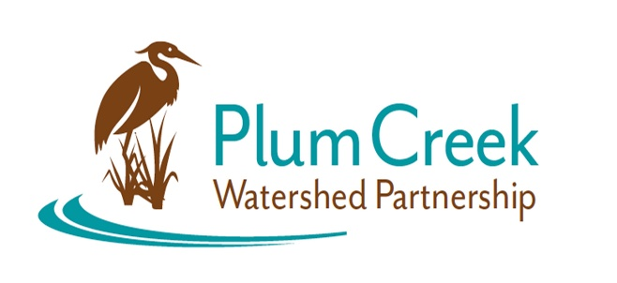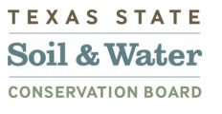

**Plum Creek Watershed Partnership**

**Public Stakeholder Meeting**

5:00 PM – 7:00 PM

Thursday, July 25, 2024

Kyle City Hall

100 W Center Street, Kyle, TX 78640

**Agenda**

**5:00** Sign in and Refreshments – Call meeting to order

* Watershed Coordinator and Steering Committee introductions
* Watershed updates
* Special guest presentation: *One Water: Regional Collaboration*
* Stakeholder open discussion
* Opportunities and events in the watershed

**7:00** Adjourn

Next Public Stakeholder Meeting: Winter 2025

Location: TBA

Funding for this effort is provided through a federal Clean Water Act nonpoint source grant administered by the [Texas Soil and Water Conservation Board](https://www.tsswcb.texas.gov/tsswcb-home-page) from the [U.S. Environmental Protection Agency](https://www.epa.gov/).