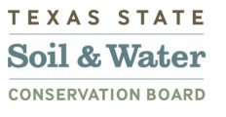

Plum Creek Watershed Partnership
Steering Committee Meeting

9:30 AM – 12 PM
Thursday, January 12th
Lockhart State Park Recreation Hall
2012 State Park Rd, Lockhart, TX 78644
Agenda
9:30 Sign in and Refreshments – Call meeting to order
Welcome and Introductions
Introduction from the New Watershed Coordinator: Sean Melvin
- A brief introduction on the Caldwell County
Feral Hog Tag Collection 2023
- Recap and Updates since last meeting (June 3rd 2022)
- New Grant Cycle: Upcoming tasks
Discussion of tasks and deliverables for 22-09 Contract
- Updated Interlocal Agreement and Steering Committee Ground Rules
Homework: Brainstorming updates to the Ground Rules
- Work Groups – Discussion time
12:00 Adjourn

Next Meeting: Early April
Location: TBA

Funding for this effort is provided through a federal Clean Water Act nonpoint source grant administered by the Texas Soil and Water Conservation Board from the U.S. Environmental Protection Agency.

