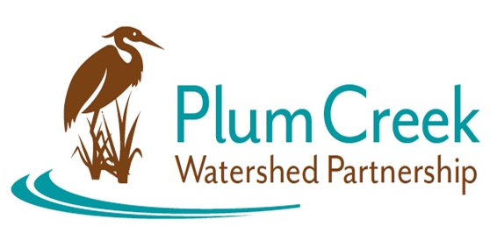

Plum Creek Watershed Partnership
Public Stakeholder Meeting

5 PM – 7 PM
Wednesday, February 28, 2024
Kyle Public Library, Community Room
550 Scott St, Kyle, TX 78640
Agenda
5:00 PM – Sign in and refreshments, meeting will commence
- Introductions from Watershed Coordinator and Steering Committee members
- An update on the watershed and overview of the 2024 Update to the Watershed Protection Plan
- A presentation from Hill County Alliance on “Effective Public Advocacy”
- Open discussion time
- Steering Committee and Stakeholder mingle
7:00 PM – meeting will be adjourned

Funding for this effort is provided through a federal Clean Water Act nonpoint source 319 grant administered by the Texas Soil and Water Conservation Board from the U.S. Environmental Protection Agency.

